**AutoQTL: an autoML approach to QTL analysis and epistasis detection**

Supplementary File S1

Encoders

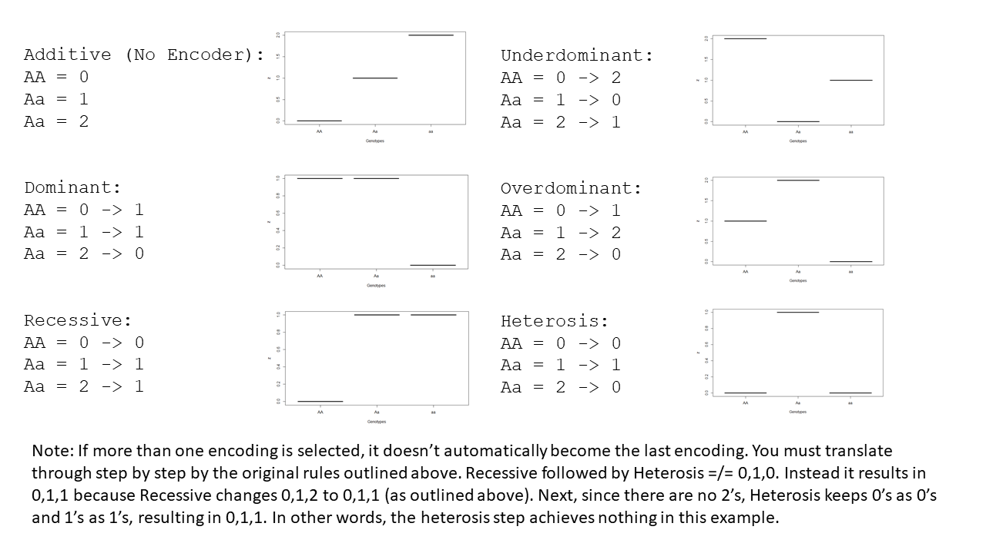

Note: If more than one encoding is selected, then a serial encoding occurs. It does not revert to additive and then apply the new encoder. Instead, genotypes are translated step by step by the original rules outlined in the images above. Below is an example where the Recessive Encoder is followed by Heterosis. In this example, the second encoding has no effect because there are no 2’s to change to 0’s.

Recessive -> Heterosis

AA = 0 -> 0 -> 0

Aa = 1 -> 1 -> 1

Aa = 2 -> 1 -> 1

In this next example, the second encoding does generate a unique final encoding.

Overdominant -> Underdominant

AA = 0 -> 1 -> 1

Aa = 1 -> 2 -> 0

Aa = 2 -> 0 -> 2